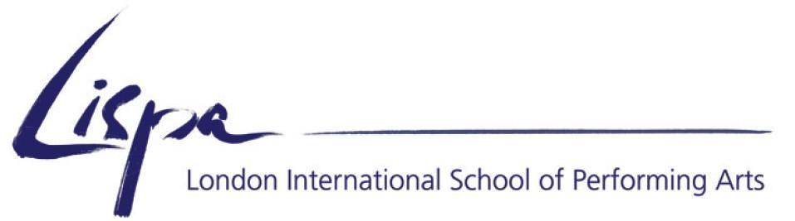

Berlin Summer School 2018
Booking Form

Name
Workshop(s) applied for :
Address
Nationality
Age
Mobile
Email

How did you hear about this workshop? (Please tick or highlight all that apply!)
□ An email from LISPA
□ Facebook
□ Google/Search engine
□ From a present or former LISPA student
□ Other (please state) ………………………………..

Please scan this completed form and attach a CV of relevant experience, a short statement of interest and a recent photograph, and email everything to the school at welcome@lispa.co.uk.

We no longer accept applications by post!

We will contact you via email to confirm an offer of a place on the workshop upon receipt of all your information.

Once you have received from us a notification of being accepted onto the course, you must make a full payment to secure your place - please wait for confirmation of your offer before making a payment. Non-payment of course fees may result in your place being offered to someone else. Note also that since the Summer school is always heavily subscribed, all payments are non-refundable. Reimbursements or partial reimbursements are sometimes possible in individual cases if we are able to fill your cancelled place with someone else from our waiting list.

All fees are in Euros and we use an online payment tracking system at peertransfer.com. Full details will be sent to you with your offer of a place on the course.

